**SMALL ENGINE DISASSEMBLY**

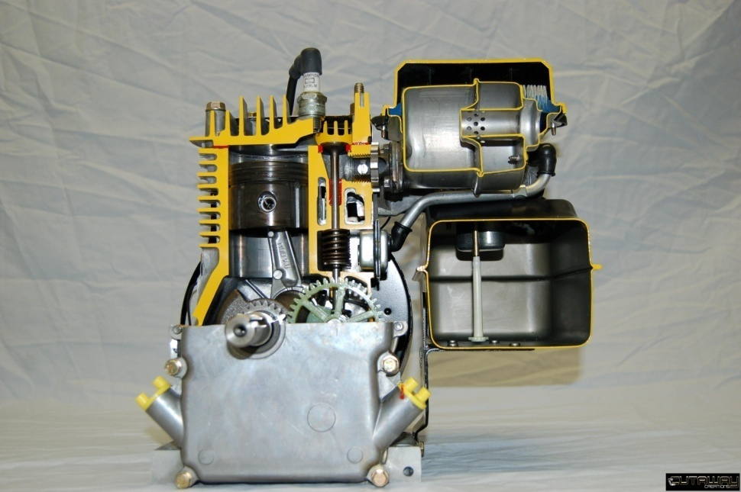

**Student Objectives**

After over-hauling this engine, you will be able to:

Understand the safety rules to follow when working around small gas engines.

Properly use a "compression tester" on a small engine.

Disassemble and re-assemble a small engine using the proper tools.

Properly remove a carburetor and its linkages from a small engine.

Properly disassemble the valve train assemblies in a valve-in- block engine design.

Remove and re-install the internal parts of a small gas engine.

***Before beginning this section of the module, you need to have successfully completed MEC1015 and workbooks 1 and 2 of this module. *It is vitally important that all safety precautions and instructions be followed while working on the engine. Any intentional abuse of safety practices or any dangerous behavior can result in a suspension from further activities.*\*\*\*

**Technical Terms**

Using the internet, shop manuals, service bulletins, write a brief definition for the following terms. Locate the part on the diagram on the following page and put the number of the part in the part number column. If the part is not shown, explain the purpose of the part.

/54

|  |  |  |
| --- | --- | --- |
| Part | No. | Description |
| engine piston |  |  |
| connecting rod assembly |  |  |
| spark plug |  |  |
| piston rings |  |  |
| engine valves |  |  |
| cylinder head |  |  |
| head gasket |  |  |
| fuel tank supply valve |  |  |
| fuel tank, fuel lines |  |  |
| air cleaner |  |  |
| carburetor |  |  |
| carburetor throttle shaft |  |  |
| engine governor |  |  |
| engine muffler |  |  |
| flywheel, |  |  |
| magneto |  |  |
| one- way clutch (flywheel nut) |  |  |
| crankshaft |  |  |
| electronic ignition |  |  |
| valve cover |  |  |
| valve spring |  |  |
| valve keeper |  |  |
| engine cylinder wall |  |  |
| camshaft |  |  |
| lifters |  |  |
| crankcase |  |  |
| oil slinger |  |  |

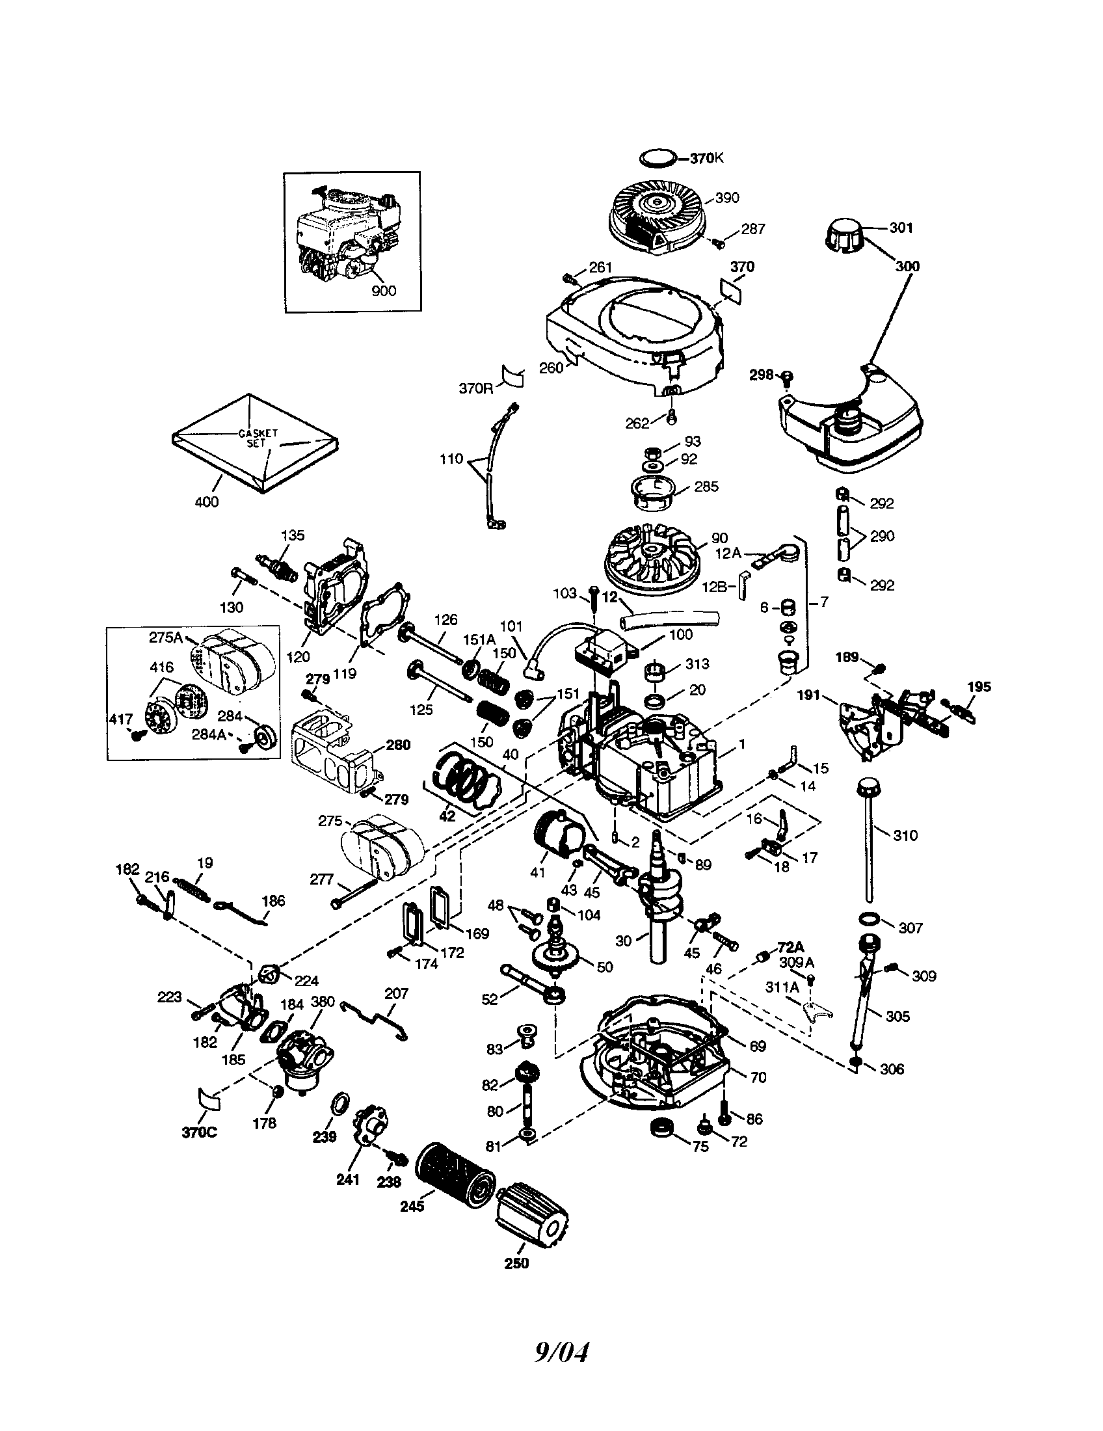

*The following assignments deal with the disassembly and reassembly of the engine. Read over the questions before you begin and try to keep them in mind as you work on the engine. A good practice is to quickly read the questions at the start of each class, answer the ones you can and keep the remainders in mind as you work.*

**Progress Checklist** – *This checklist needs to be checked/initialed by the instructor at the points indicated.*

|  |  |
| --- | --- |
| **Steps - Disassembly** | **🗸** |
| Inventory sheet of tools in student station completed |  |
| Remove fan shroud; identify flywheel, magnets, fins |  |
| Remove air cleaner; find element and determine if it is oil or paper |  |
| Explain fuel path |  |
| Drain gas into container |  |
| Remove spark plug; remove head – keep bolts organized |  |
| Trace path of electricity in engine |  |
| Remove carburetor; detach fuel line; detach linkages |  |
| Remove muffler |  |
| Drain the oil |  |
| Clean end of crank shaft; remove crank case bolts; remove crank case cover |  |
| Remove oil slinger, cam shaft, lifters |  |
| Remove valve cover |  |
| Remove valve spring retainers; remove valves, springs |  |
| Compare valves, springs |  |
| Remove connecting rod cap |  |
| Remove piston (remove ridge if needed) |  |
| Remove connecting rod wrist pin; reinsert retainer |  |
| Identify rings |  |
| Remove rings |  |
| Remove crank shaft |  |

The following questions deal with the disassembly and reassembly of the engine. Answer the questions in the space provided

***Disassembly***

1. Name 5 safety rules that should be followed when working around small gas engines.

/5

1. What specific information is found on your engine?

/3

/1

/1

/1

/1

/2

/1

/2

/3

/1

/1

/1

1. What piece of equipment is your engine it designed to be used on?
2. What should be removed first when disassembling a small gas engine?
3. What is a fan shroud?  
     
   a) The shroud directs air that is being forced by which part of the engine?  
     
   b) What else is there on the engine that helps support cooling? How does it work?
4. Why is it important to note the location of any linkages or springs when removing a carburetor from a small engine?
5. Describe how to remove a fuel tank and fuel lines from a typical small engine.
6. Explain how to use a compression tester on a small gas engine.
7. Name a method used to remove a flywheel from a small engine.
8. Why should all parts and fasteners be organized during a small engine teardown?
9. What type of damage can result if a small engine is operated with little or no oil in its crankcase?
10. What were the easiest parts to remove in your four-stroke /cycle small engine crankcase?

/2

/3

/1

/2

/1

/2

/1

1. What tools are usually required when removing the connecting rod from a small engine's crankshaft?
2. What is the orientation of the crankshaft in your engine?
3. What is a bearing? Can bearings have no moving parts?
4. What is the purpose of an oil slinger?
5. What problems can arise from having bad rings on a piston?
6. What could happen if an engine is reassembled without using any oil or lubricant?

***Occupational Connection Worksheet***

/89

Complete an Occupational Connection Worksheet for this module, discuss it with your instructor and have them initial this book.